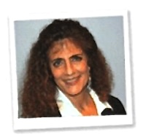  Strike Out Cancer program's Most Valuable Players  Twenty individuals who provide hope and support to cancer patients and their loved ones have been named as the Strike Out Cancer program's Most Valuable Players. | Lind Butler  Houston, TX  Lind gives support, hope and inspiration to cancer patients and their loved ones. She founded a Healing With Arts Program for cancer survivors and their caregivers that allows them to use their feelings about cancer in an artful way that is both beautiful and healing. Lind also helps to coordinate an annual cancer counseling workshop for those in the cancer community. The workshop includes a keynote speaker and breakout sessions that cover an array of pertinent topics.

